|  |
| --- |
| <Victoria State Accident Analyzing Tool> Executive Summary |
| Yunshuo Zhang(s5319113) Sunwoo Nam(s5305407) Ze Zeng(s5316065)7810ICT Software TechnologiesOctober 7, 2023 |

# Abstract

In our analysis of accident data for the period from January 1, 2015, to December 31, 2015, we made several key findings. First, our examination of all accidents during this period provided a foundational understanding of the data.

Next, in the analysis of alcohol involvement, we discovered that 96.8% of accidents were not related to alcohol, underscoring the importance of continued vigilance. Conversely, 3.2% of accidents were alcohol-related, highlighting the need for targeted interventions to reduce such incidents.

Lastly, our regional analysis revealed variations in accident proportions. The Eastern Region accounted for the highest share at 35.9%, followed closely by the Metropolitan North West Region at 35.6%, while the Western Region had the lowest proportion at 5.1%. These insights can inform localized safety measures and resource allocation. Additionally, there was a suggestion that displaying row counts during filtering on the "Main Screen" would enhance usability and data exploration.

# Introduction

# This report aims to provide a comprehensive overview of accident data within a specific timeframe, from January 1, 2015, to December 31, 2015. Throughout this period, a series of analysis tasks have been performed to gain insights into various aspects of accidents.

# Analysis 1: "Accident Data for User-Selected Period"

# In this analysis, we have compiled all accidents that occurred during the selected timeframe. The objective was to provide an inclusive overview of accidents within the specified date range.

# Analysis 2: "Hourly Accident Distribution"

# To further understand accident patterns, we produced a chart that illustrates the average number of accidents for each hour of the day. This analysis offers insights into how accidents vary throughout the day.

# Analysis 3: "Accidents Caused by 'Collision'"

# Here, we focused on accidents specifically caused by types containing the keyword "collision" during the selected period. This targeted search allowed us to extract relevant data related to these types of accidents.

# Analysis 4: "Proportion of Accidents by Alcohol Involvement"

# To explore the impact of alcohol on accidents, we provided a pie chart depicting the distribution of accidents based on their involvement with alcohol. This analysis helps identify trends over time and accident types associated with alcohol-related incidents.

# Analysis 5: "Proportion of Accidents by Region for the Selected Period"

# Lastly, we filtered accident data based on the region in which each accident occurred during the selected timeframe. This analysis provides a regional perspective, showcasing the proportion of accidents in different regions.

# Overall, this report offers a comprehensive understanding of accidents within the specified date range, covering a range of aspects, including time-based trends, specific accident types, alcohol involvement, and regional distribution. These analyses aim to provide valuable insights for decision-makers and stakeholders concerned with accident-related matters.

# **Analysis 1 <** **Accident Data for User-Selected Period>**

* All accidents that happen during the selected period

Selected period: 01/01/2015 – 31/12/2015

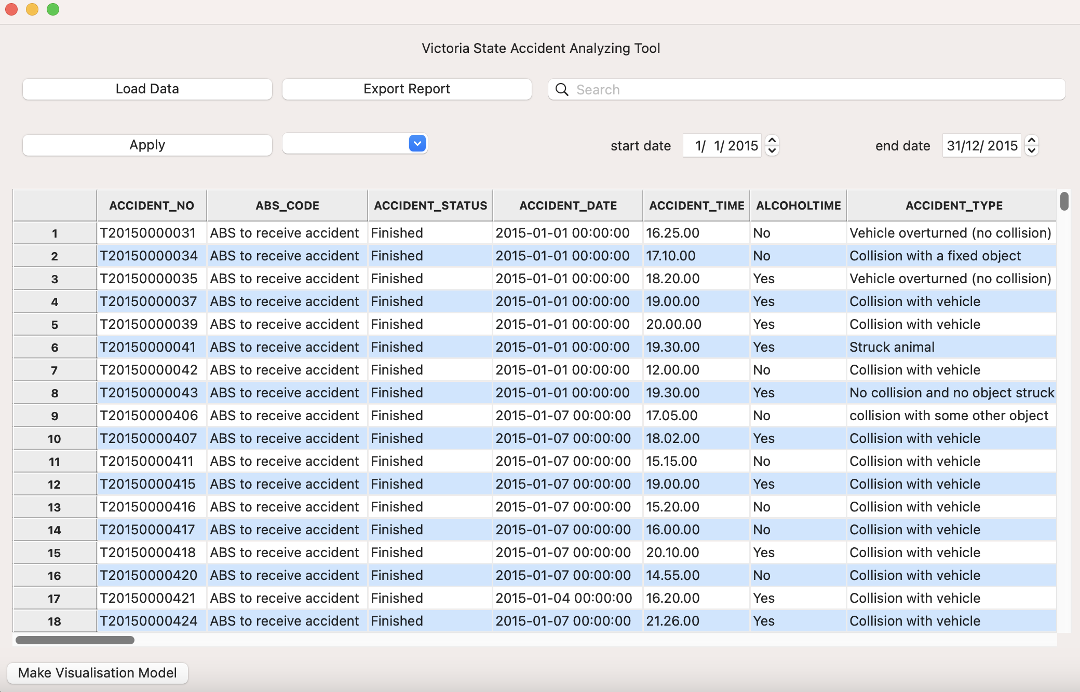

# **Analysis 2 <Hourly Accident Distribution>**

* For a user-selected period, produce a chart to show the number of accidents in each hour of the day (on average).

# **Analysis 3 <** **Accidents Caused by 'Collision'>**

* For a selected period(01/01/2015 – 31/12/2015), retried all accidents caused by accident type contains a keyword “collision”.

Keyword: collision

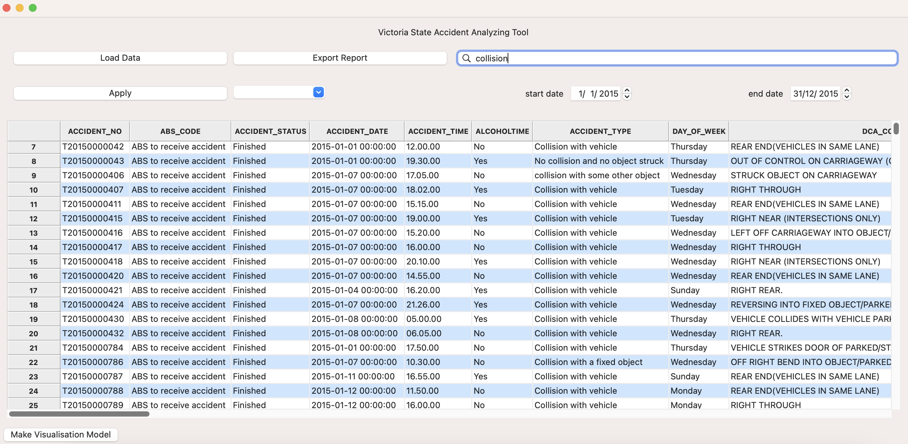

: Filled in the keyword for the accident type “collision” and clicked the magnifier(“Search”) button, table shows the updated results.

# 

# **Analysis 4 <Proportion of Accidents by Alcohol Involvement>**

* This pie chart illustrates the distribution of accidents based on their involvement with alcohol. The chart shows the proportion of accidents categorized as either 'Alcohol-Related(Yes)' or 'Not Alcohol-Related(No)' for a selected period.

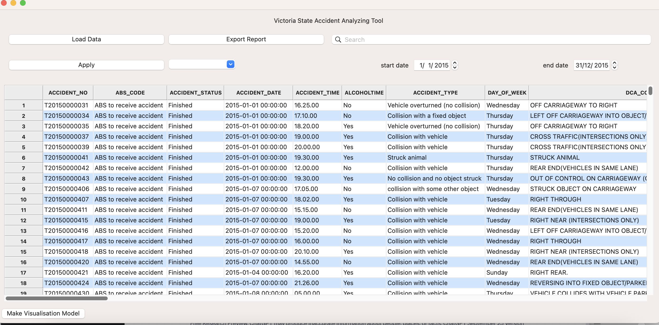

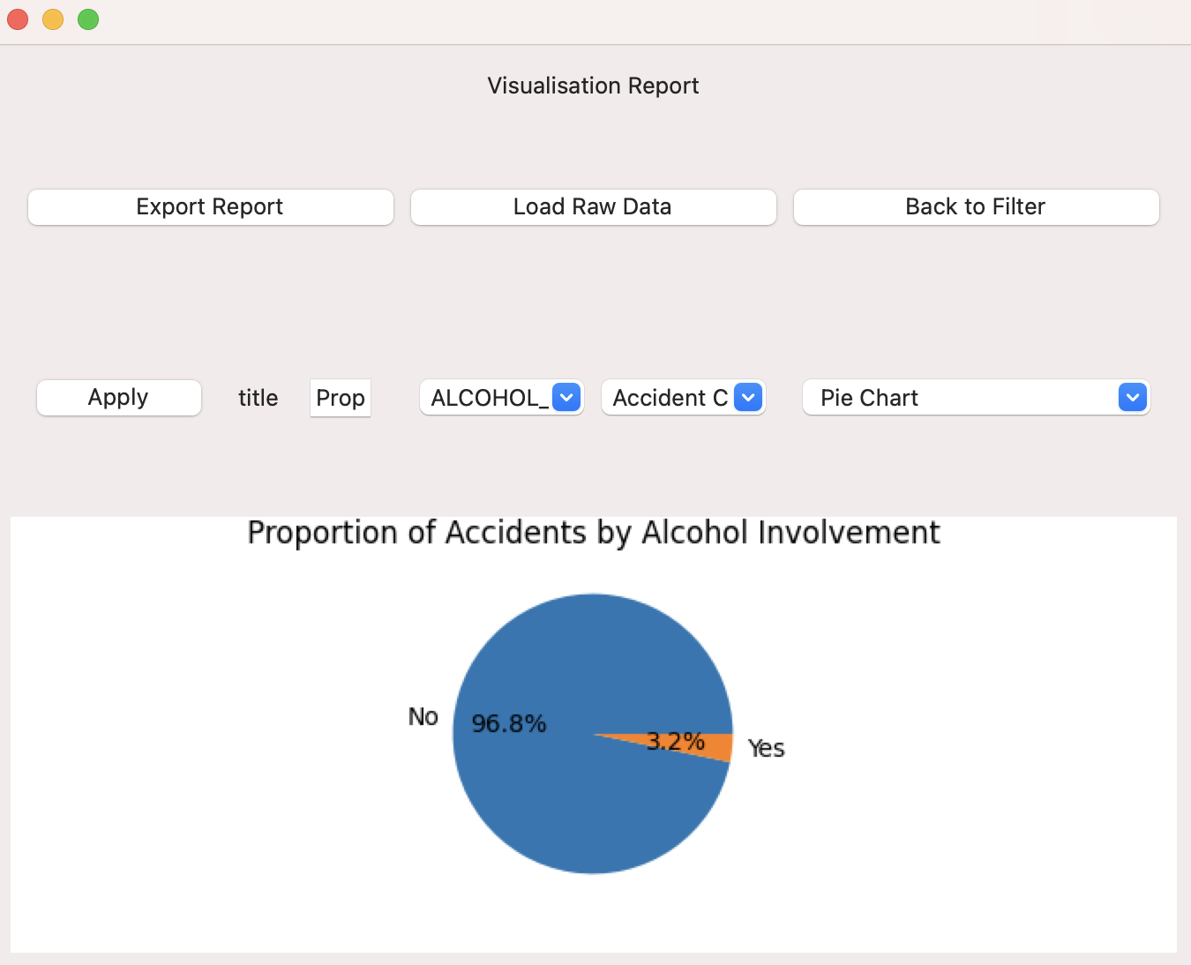

# **Analysis 5 <** **Proportion of Accidents by Region for the Selected Period>**

* Filter the data by the region of the accident during the selected period of time, and show the proportion of accidents by the region.

**1) Western region**

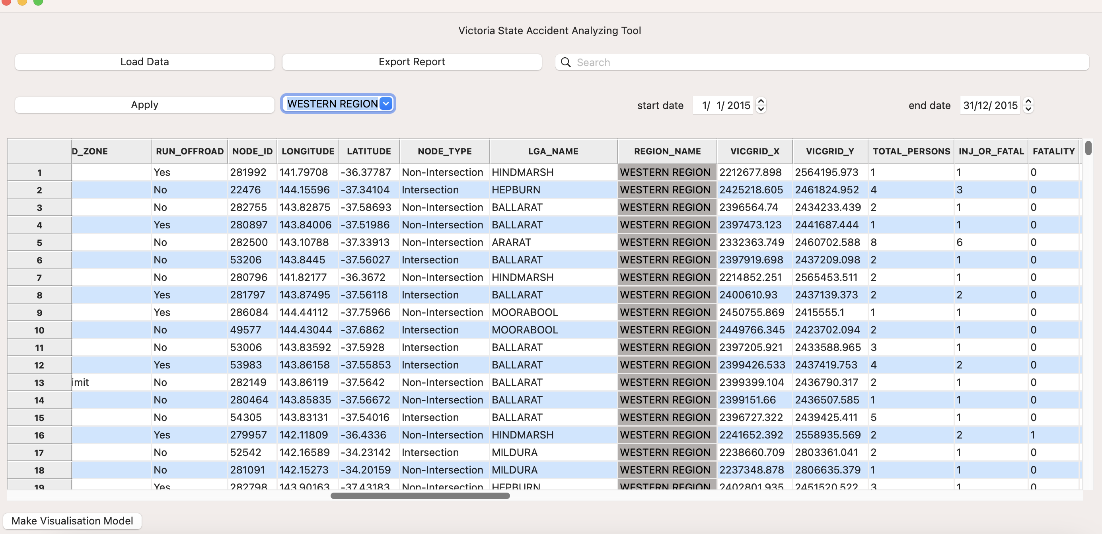

# 2) Proportion of Accidents by Region

